Mod – 1

Law of supply and demand:

**Factors influencing demand**The shape of the demand curve is influenced by the following factors:  
· Income of the people  
· Prices of related goods  
· Tastes of consumers

**Factors influencing supply**The shape of the supply curve is affected by the following factors:  
· Cost of the inputs  
· Technology   
· Weather  
· Prices of related goods

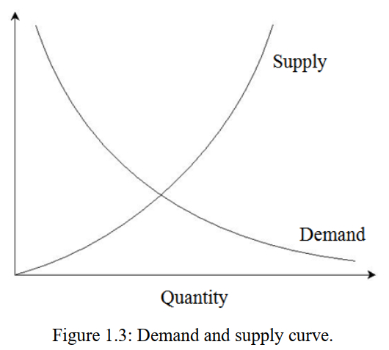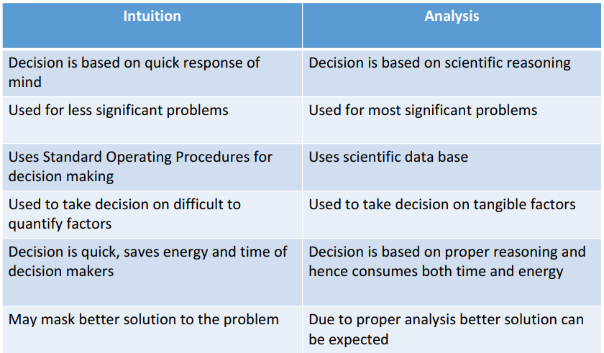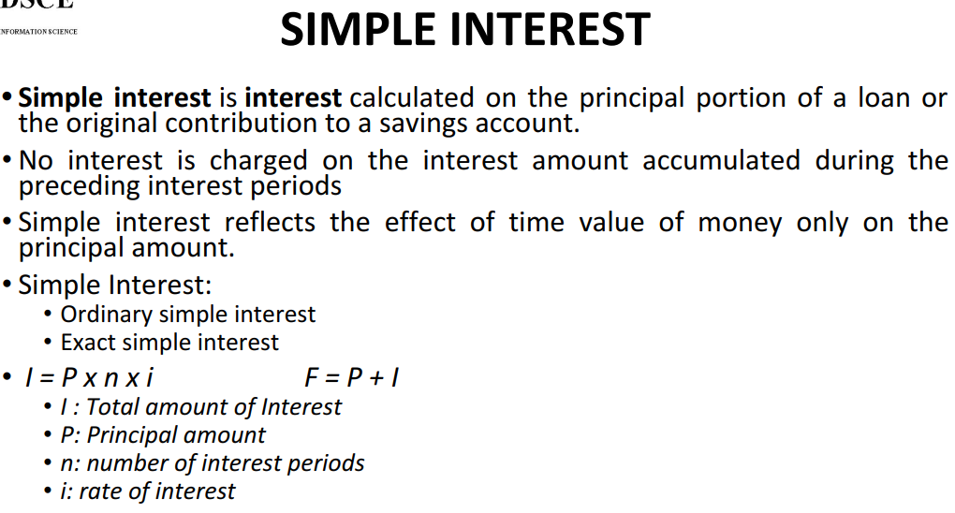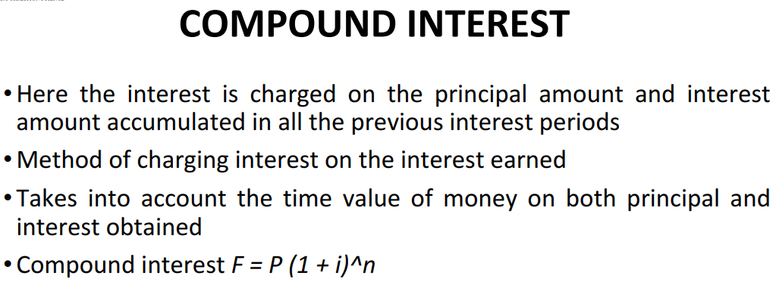

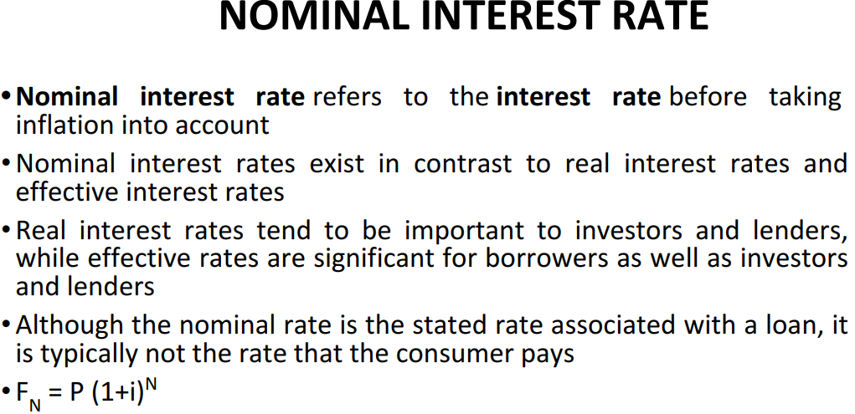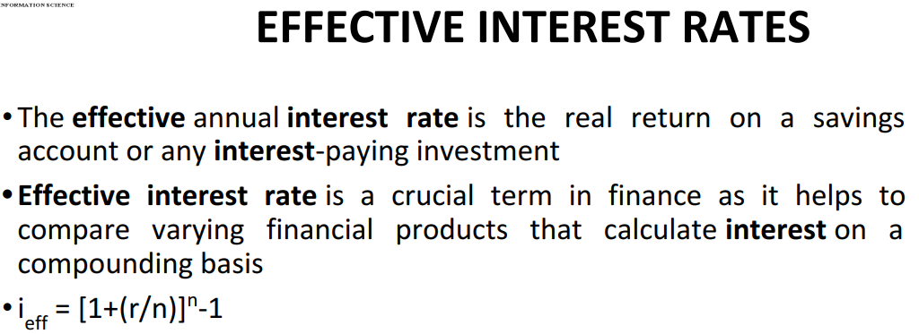

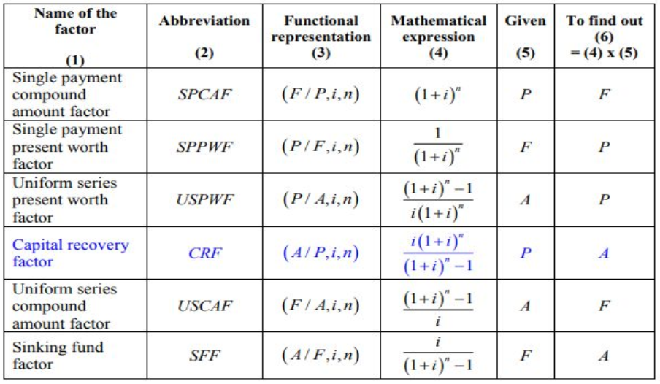

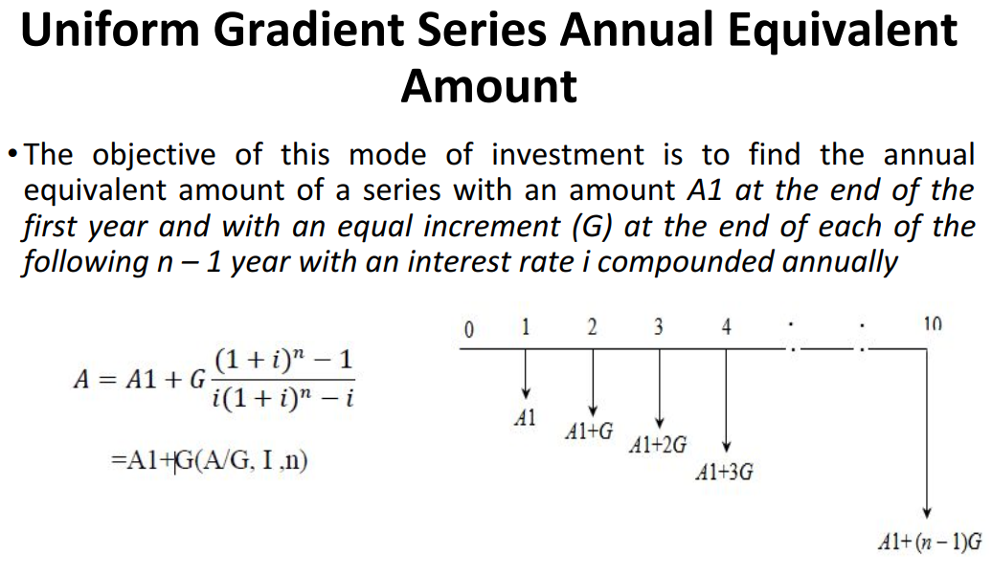 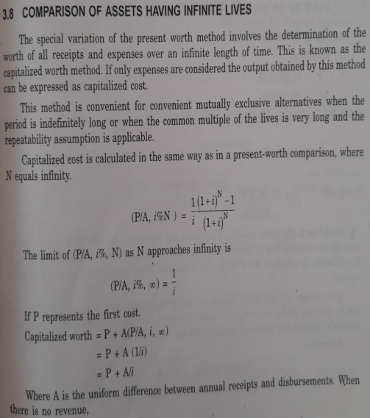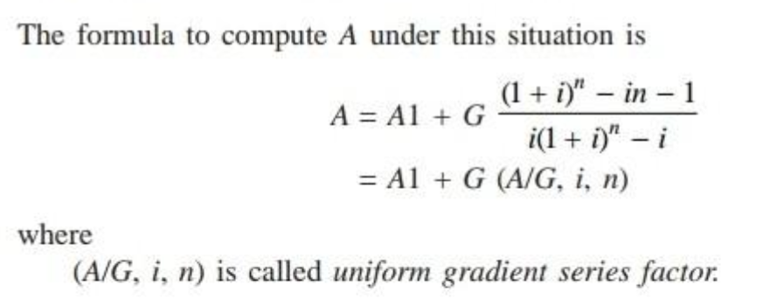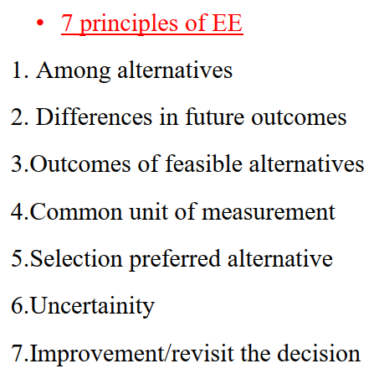

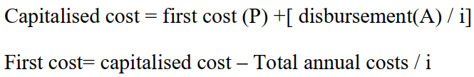

Problem solving:

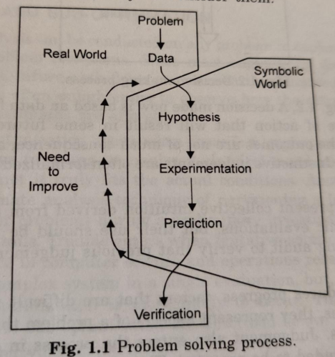 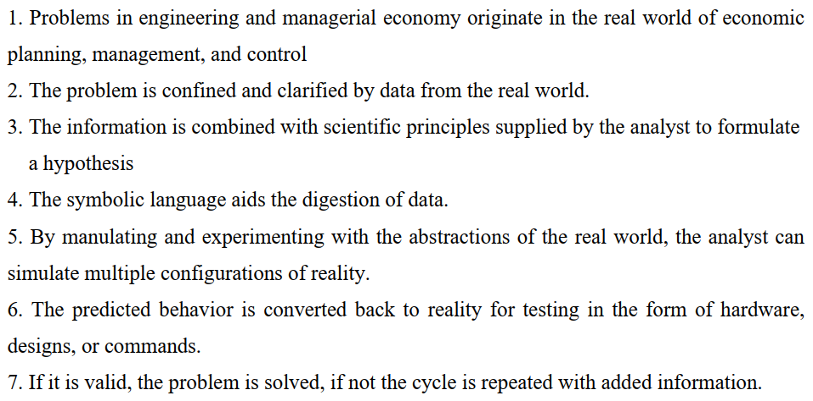

Decision making:

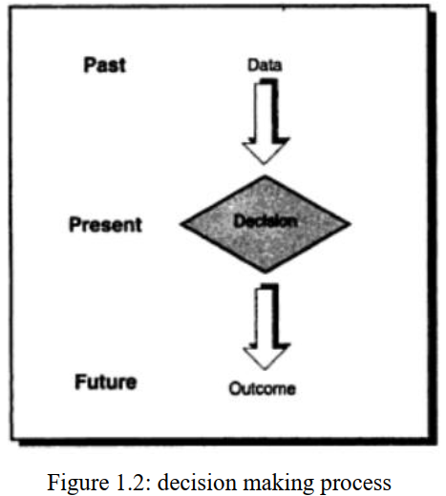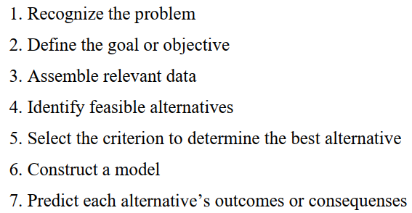

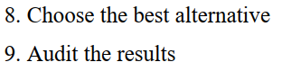

Mod – 2

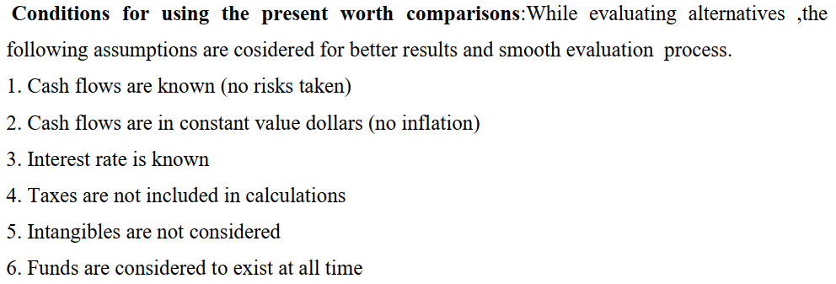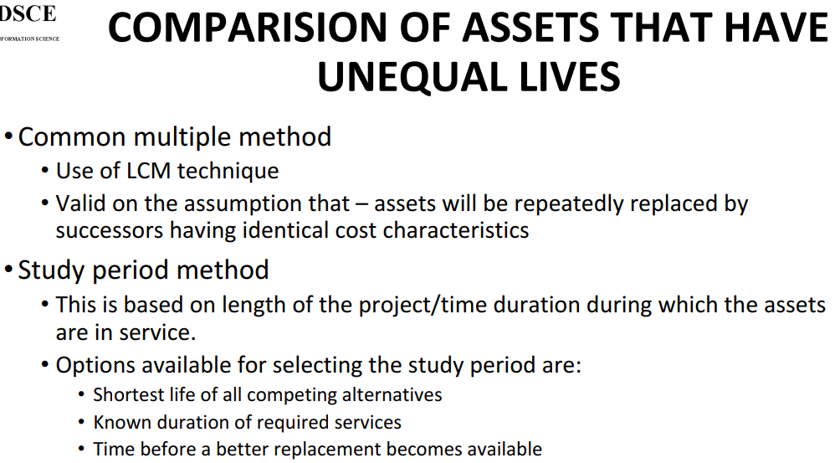

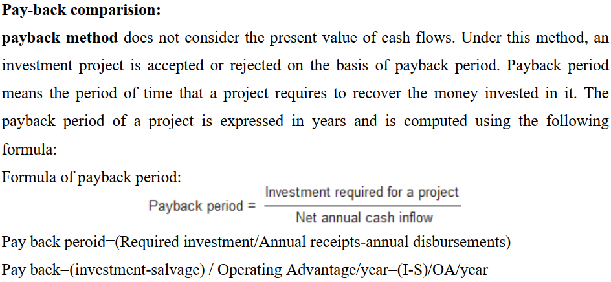

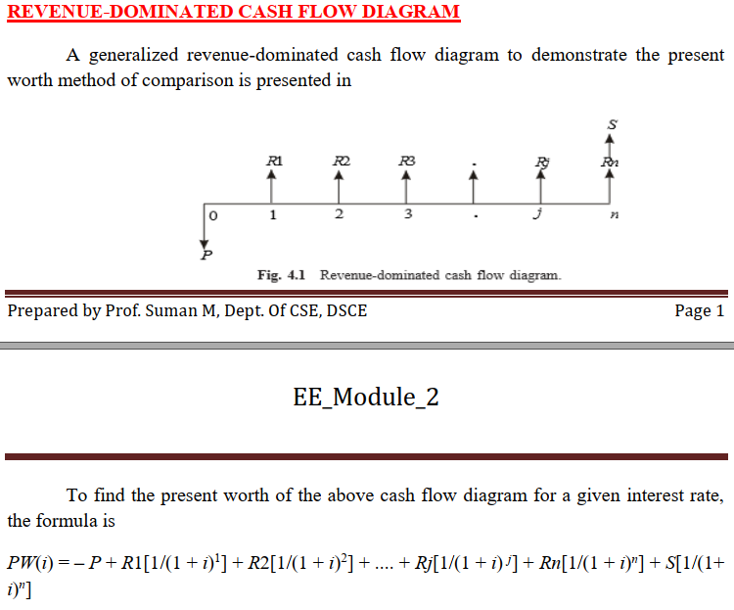 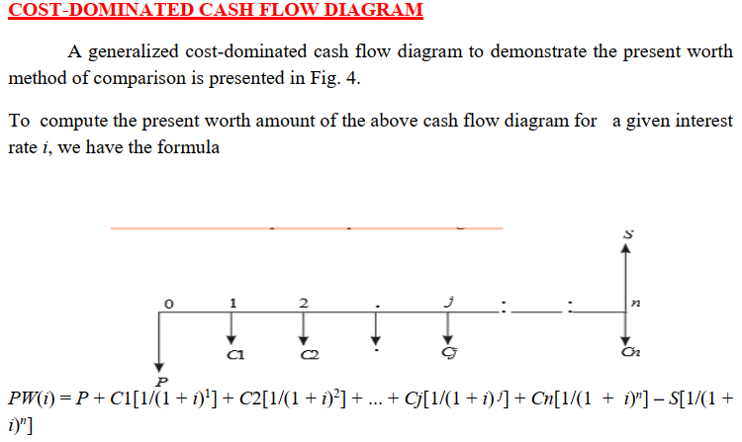

 

**Checkout the problems for this chapter**

Mod – 3

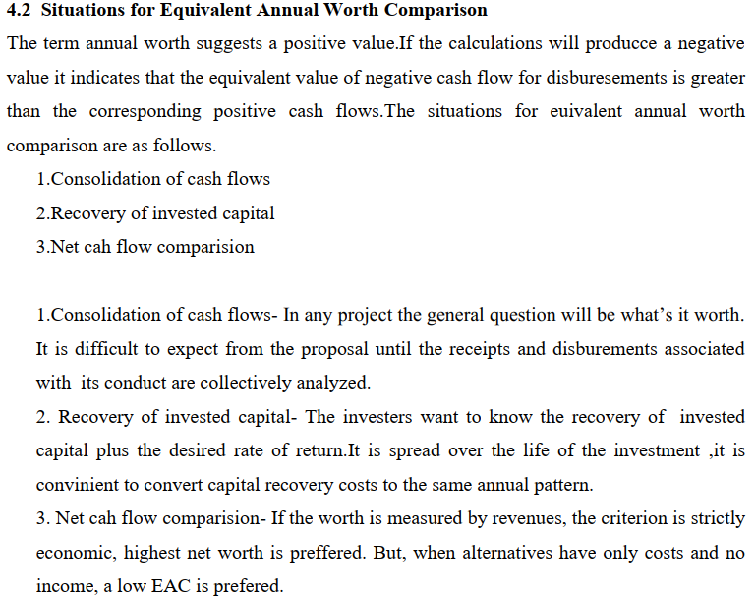

**Consideration of asset life  
Economic life** –

* The asset's economic life is defined as the number of years in which the asset returns more value to the owner than it costs to own, operate, and maintain. When these costs exceed returns, the acquisition is beyond its economic life.
* An asset's economic life can be shortened or terminated by a number of different factors, including: Wear, degradation, or damage which can lower asset performance and raise maintenance and operation costs.
* Obsolescence, which can raise maintenance costs and render asset performance relatively inefficient when compared to more current alternatives.
* Changes in company operations, product offerings, or the company's business model, which reduce the value certain assets can deliver.

**Service life or ownership life** –

* An asset's service life is defined as the number of years the acquisition will actually be in service, and all may contribute to the owner's judgement as to what the ownership life should be.
* Ownership life begins when the decision to acquire the asset begins causing costs.
* This may include costs that occur before the actual arrival or asset use begins, such as loan origination fees, planning costs, transportation costs, or set up costs.
* Ownership life ends when the asset stops causing costs and in fact has no continuing financial impact of any kind.

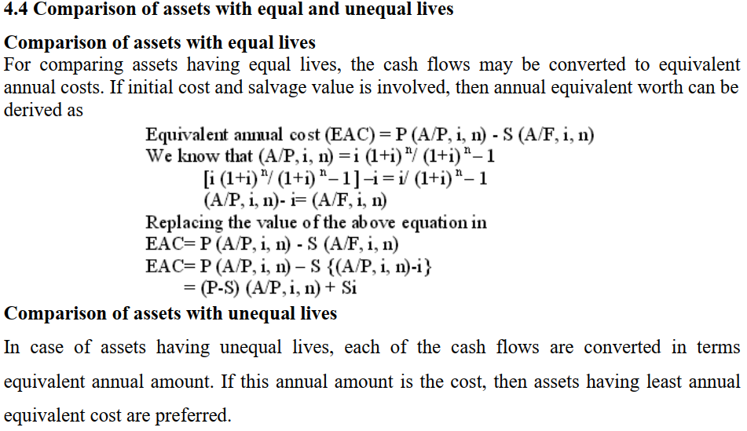 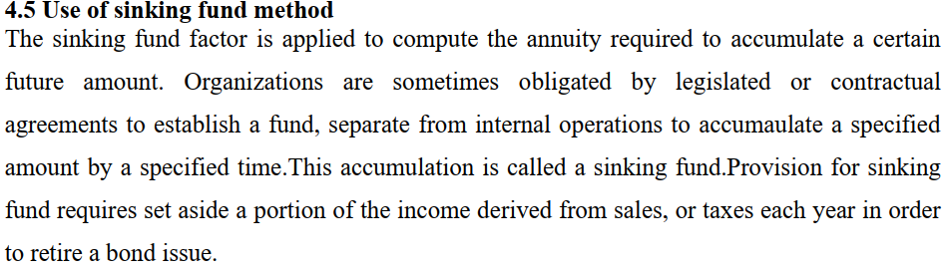

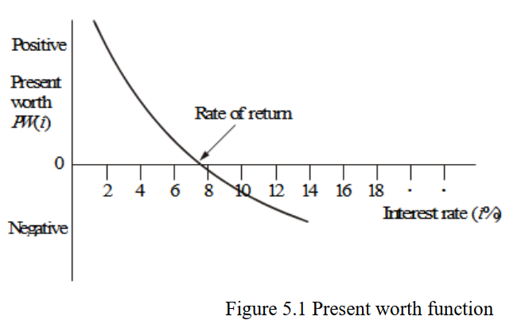 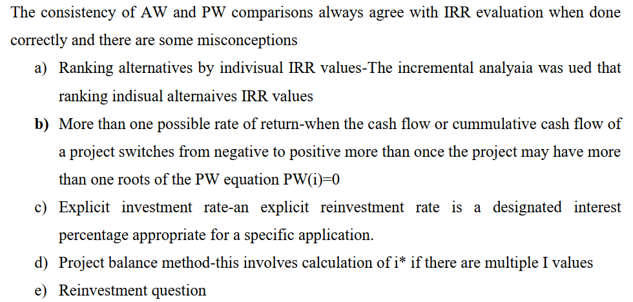

Eg: 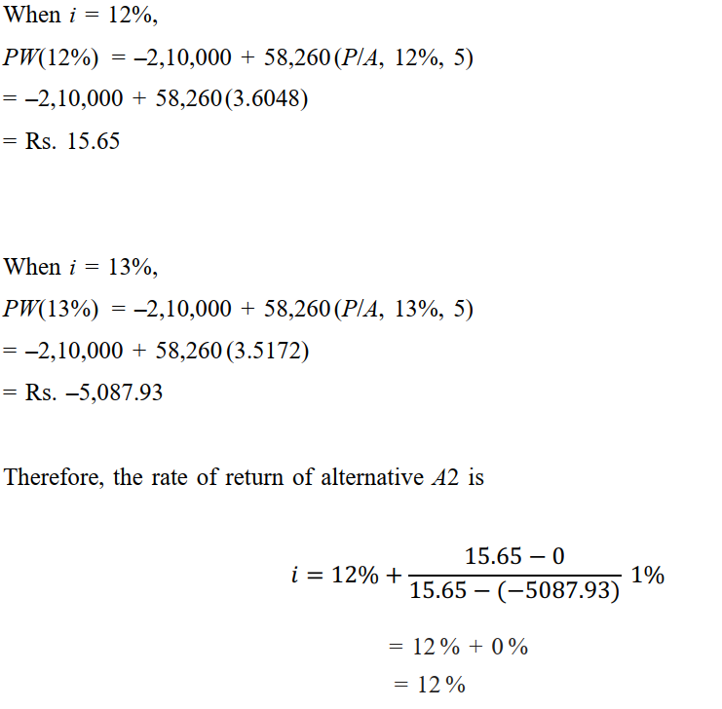

Mod – 4

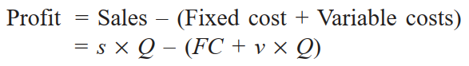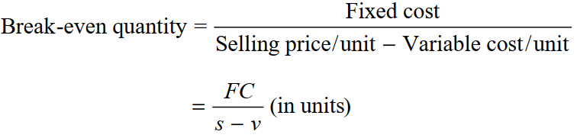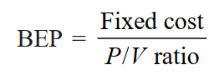

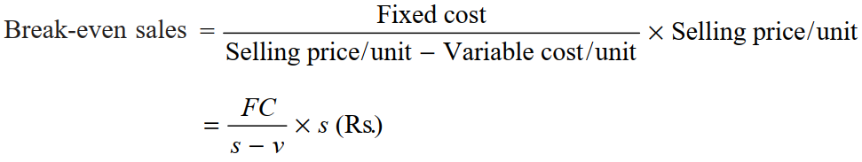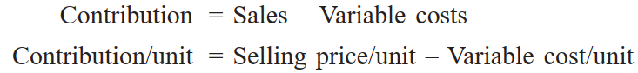

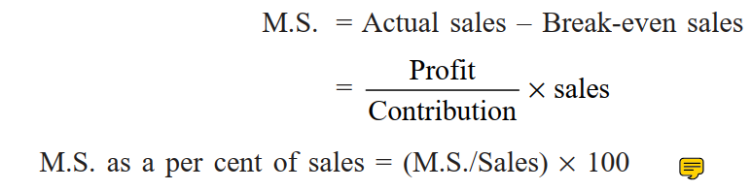 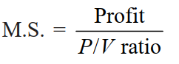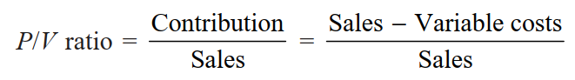

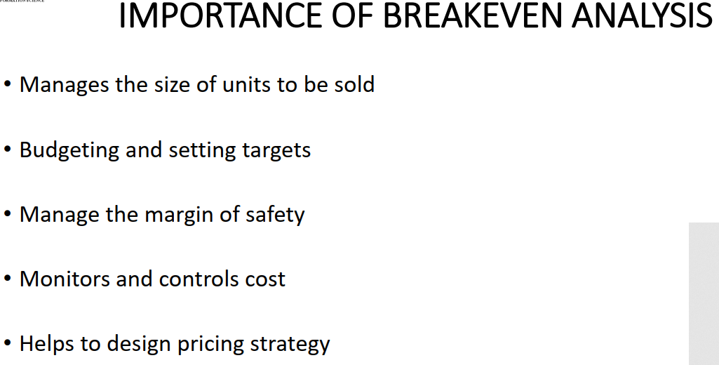

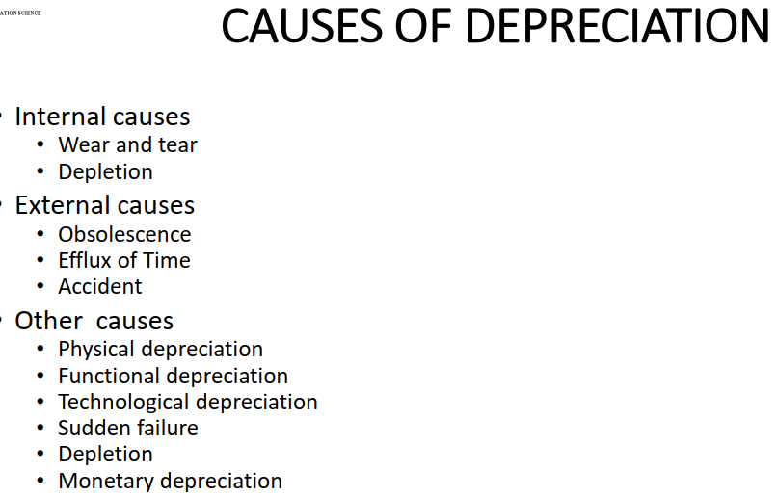

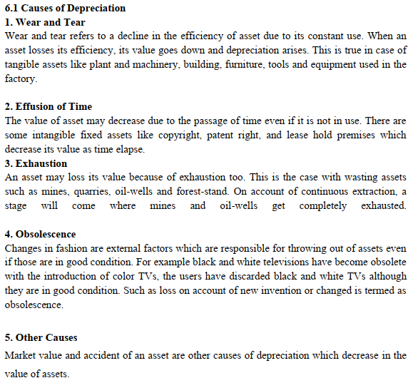

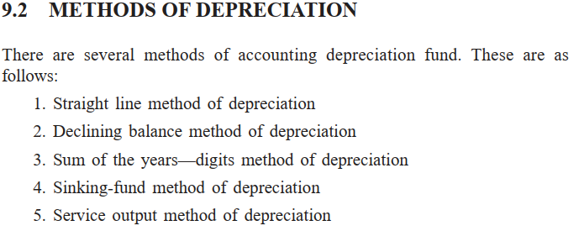

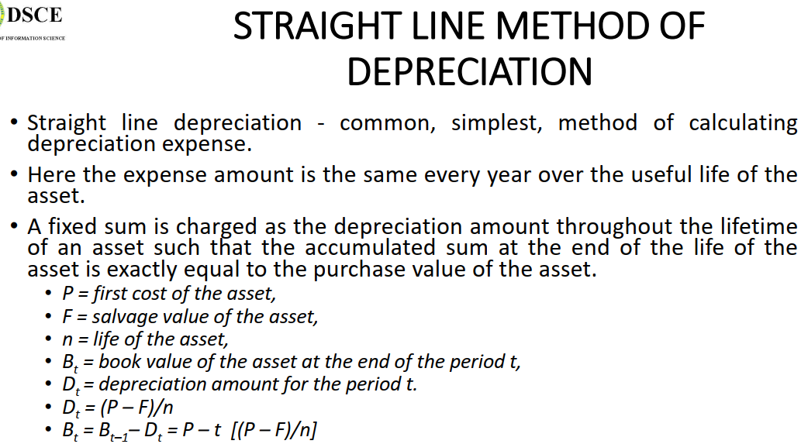

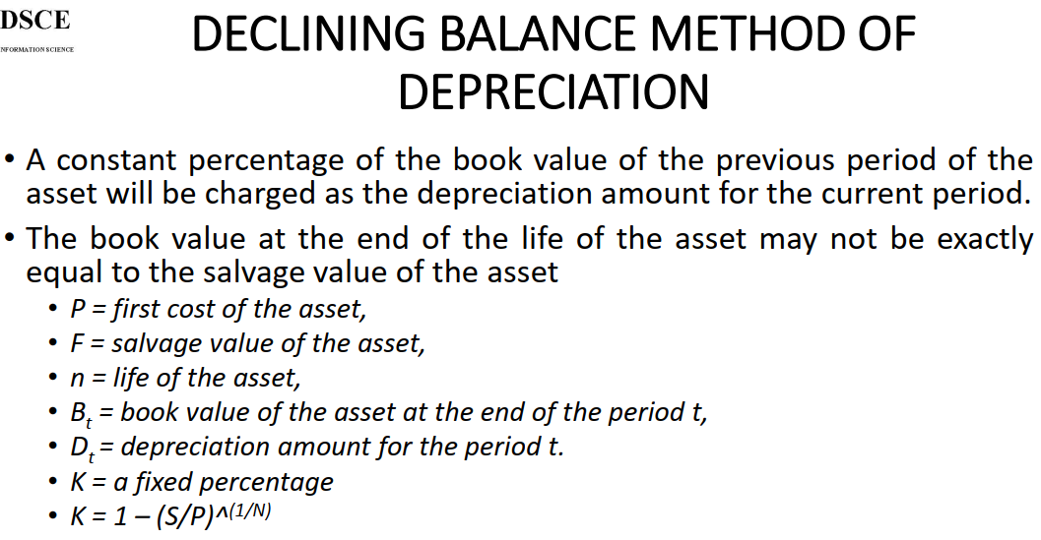

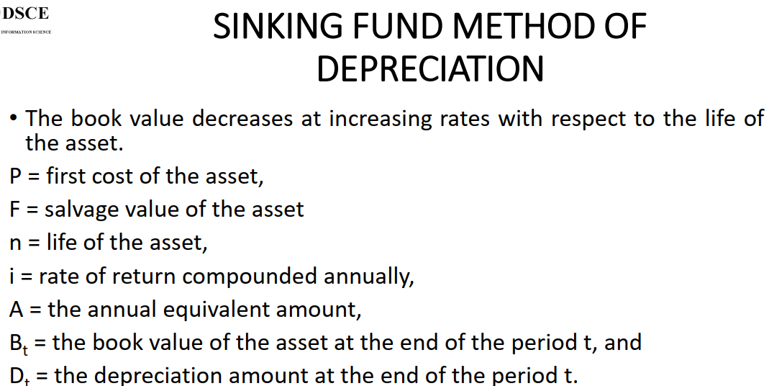

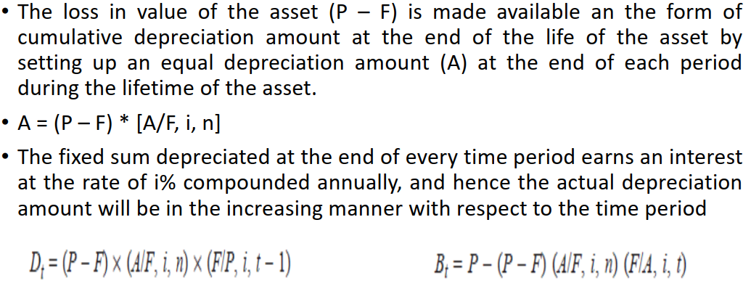

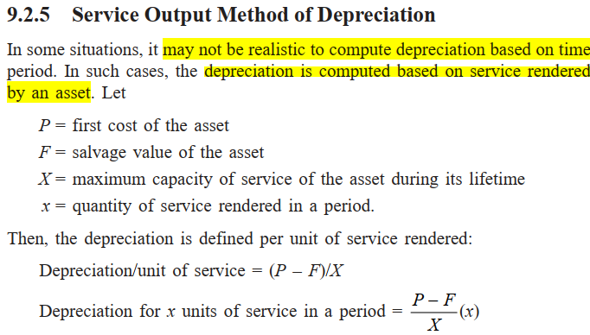

Mod – 5

**Replacement Analysis:  
5.1 Introduction:**Replacement analysis is one of the crucial analysis in capital budgeting. An asset life may be  
reduced due to physical impairment, changes in economic requirements and rapid changes in  
technology that may obsolete an asset prior to expectation. The replacement of assets offers  
economic opportunity for the firm. In replacement analysis there is two alternatives:  
• The assets that are currently using : The defender  
• The assets that we have to buy to replace current assets: The challenger  
Factors to be considered in replacement analysis are listed below.  
• Sunk costs to be ignored  
• Existing asset value need not be considered  
• Income tax to be avoided  
• The optimal replacement cycle is one which has lowest equivalent annual cost  
• The replacement decision will apply indefinitely.  
• Economic life of the challenger and the defender should not consider  
**5.2 Reasons for Replacement**The replacement of an existing asset may be appropriate in various situations including:  
Ø Obsolescence,  
Ø Depletion, and  
Ø Deterioration due to aging.  
In each of these cases, the ability of a previously implemented business asset to produce a  
desired output is challenged. For cases of obsolescence, depletion, and aging. it may be  
economical to replace the existing asset. We define each of these situations

Obsolescence:Obsolescence occurs when the technology of an asset is surpassed by newer and/or different  
technologies. Changes in technology cause subsequent changes in the market demand for  
older assets.

Depletion:The gradual loss of market value of an asset as it is being consumed or exhausted. Oil wells  
and timber tracts are examples of such assets.

**Deterioration due to aging:**The general condition of loss in value of some asset due to the aging process. Production  
machinery and other business assets that were once new eventually become aged. To  
compensate for a loss in functionality due to the aging process, additional operating and  
maintenance expenses are usually incurred to maintain the asset at its operating efficiency

